5th April 2013

**YOKOHAMA Rubber to Exhibit at Aircraft Interiors Expo 2013**

Tokyo - The YOKOHAMA Rubber Co., Ltd., announced today that it will exhibit its products at Aircraft Interiors Expo 2013 to be held for three days starting April 9 at Hamburg Messe, in Germany. The Aircraft Interiors Expo is a world-class trade show featuring in aircraft interior products, related materials, leading-edge technology and more. YOKOHAMA Rubber has participated in the event since 2005.

Exhibits at the YOKOHAMA booth will include retrofit modules for upgrading interiors of Boeing 757 passenger aircraft, an upgrade lavatory kit for Boeing 737 Next-Generation (NG) aircraft, and a model of a new lavatory concept.

In the field of aircraft components, YOKOHAMA manufactures and sells a wide range of products, including water tanks, thermal insulation, lightweight composite materials and honeycomb structures. With the superiority of its lavatory modules using lightweight composite materials in particular, YOKOHAMA was the exclusive supplier of lavatory modules for the Boeing 757 and, following that, from 2004, the exclusive supplier for the Boeing 737 family of aircraft. It also develops custom-made replacement modules for airlines. In 2010, YOKOHAMA created a new passenger-cabin staircase for the Boeing 747-8I, which has been highly evaluated for its design, durability and light weight.

The Aircraft Interiors Expo is held twice a year, in Hamburg in spring and in the U.S. in fall. It provides an outstanding opportunity to highlight products for airline and aeronautics industries. At the previous Hamburg event in March 2012, more than 500 companies took part and a great many visitors from the related industries were attracted.

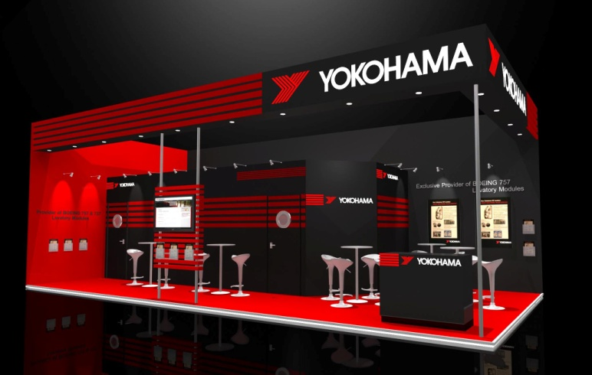

*Conceptual drawing of YOKOHAMA booth*